**Given the following Neural Network and input values, compute the output value. Use the sigmoid activation function. Show your work for partial credit.**

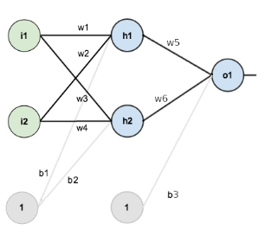

|  |  |  |  |
| --- | --- | --- | --- |
| Input | Level 1 Weights | Level 1 Weights | Bias |
| i1 = .8 | W1 = .2 | W5 = .48 | B1 = .23 |
| i2 = .3 | W2 = .35 | W6 = .34 | B2 = .41 |
|  | W3 = .15 |  | B3 = .5 |
|  | W4 = .6 |  |  |

The work for partial credit is shown in the attached Excel file, but here are screenshots for simplicity.

**Answer**:

Work for partial credit (actual calculations were done in the Excel file that was included in the submission

Using the output from the previous question, apply backpropagation assuming the target value is 0 and the learning rate is .1. What are the new weights. Show your work for partial credit.

**Answer:**

Work for partial credit (actual calculations were done in the Excel file that was included in the submission

Apply PCA to the Diabetes dataset. What are the resulting projections for the top 2 dimensions?

**The projections themselves are stored in the attached diabetes_pca_top_2_projections.csv**

Nevertheless, here is a plot of the values with component-1 on the X axis and component 2 on the Y axis.

Also of note:



Apply LDA and PCA to the iris dataset. Using the top 2 dimensions, graph the resulting subspace and include the graphs here. Which one produces a better separation between classes.

**LDA provides a better separation between the classes. This is illustrated by noting how many of the dots shown in green “bleed” into the yellow class with PDA whereas there is almost no intermixing with LDA**

